**Managing the Fleet: Rental Car Fleet Management and Analysis**

by Lingrui Fan, Elena Lazareva, Leanne Phillips, and Erik Ross

Professor Alexey Kushnir

Market Design

May 1st, 2020

**ABSTRACT**

The car rental business emerged in the early 20th century and has grown swiftly since then. With the rapid growth of the world economy and increased opportunities to travel, the car rental business has enjoyed the benefits, expanding and diversifying their fleets to meet demand. Located at airports, train stations, or throughout urban areas, cars are allocated to local branches by car rental companies to provide travelers a more convenient way of traveling through, and have been popular. However, with increasing fleet size and wide reaching networks, deploying cars to maximize the fleet’s utilization remains a high-level, difficult problem. The method of pool segmentation has significantly improved the efficiency of allocation, but the volatility of demand makes the supply of fleets difficult to manage, even with pool divisions. Although the matching system for other forms of transportation have been studied thoroughly, the research and study on the rental car market are less extensive. After our analysis of the car allocation model of some car-rental companies, we propose two complementary solutions- simplifying the diversity of the fleets and creating new overflow centers- which will better meet both consumer demands and branch needs.

**INTRODUCTION**

The car rental business started in the early 20th century, and since then has served a popular and essential part of people’s traveling plans. With the rapid growth of the world economy, population and consumption capacity in traveling has skyrocketed and boosted the demand for air services. As an indispensable complement to air travel, rental car service also benefits significantly from this growth. Moreover, with increase in air traffic and growth in the trend of online car booking, car rentals are a preferred option for travel, as a convenient and fast mode of transportation. In addition, car rentals can help curb pollution and climate change, by reducing the volumetric sales of new vehicles and selling used rental vehicles. While holding these advantages, the rental car industry also faces problems. For example, car rental companies continuously face a problem of allocating cars to be rented among their various locations. Each location needs to have a selection of rental cars available for increased demand, but not so many sitting unused that they lose profits. With the added complication of renters who want to travel in one direction, for example, there is also a flow between rental locations.

Although there is a solid research background for air traveling, the rental car market has been inadequately studied to solve the industry’s problem until the recent decade. Even though there are some existing solutions to these problems, such as ‘drop fees’ for one-way rentals, the market needs more refinement.

This paper will be divided into five sections. We will first briefly discuss the background of the whole car rental industry, then introduce the major considerations and market features for the current rental car market to help pinpoint the problems to solve. We will explain and analyze the current pool segmentation model that is used to boost the efficiency of allocation, as well as identify the problems that currently exist in the rental car market. Finally, we will propose our improvements for the rental car market to better meet consumer demands and branch needs.

**I. INDUSTRY BACKGROUND**

The rental car business began as early as 1916, when Nebraska native Joe Saunders started a car rental business with a Ford Model T, renting his car to local and visiting businessmen. Saunders’s business flourished, and by 1925, he owned car rental operations in 21 states. Soon after, his business went bankrupt during the Great Depression of the 1930s, but many other businessmen seized the car rental opportunity. Hertz’s Drive-Ur-Self System, founded soon after Saunder’s business, is still a major car rental company today.

Later, the industry was bolstered by the expansion of railway networks. Many railway companies encouraged rental cars at their stations by creating rental car booths at stations and allowing passengers to reserve rental cars in advance of their arrival by telegraph messages. The rental car business welcomed another boom after WWII, as air travel flourished and consumers used car rentals for ground transport, frequently on business trips. Since then, car rental services have closely cooperated with airlines.

Another main car rental company, Enterprise Rent-A-Car, was founded in 1957, but was a major departure from previous rental models. It adopted different advertising strategies by appealing to customers who needed a replacement car or did not have a car, rather than travellers. Enterprise opened their facilities extensively in more local areas and offered lower prices, but older cars to their customers. Its business model continues to be very successful. (Gen-Han Wu, 2010). Enterprise’s model is probably the origin of rental car allocation problems; previous companies would only need to be located at travel hubs- mainly airports- but their new model required a more far-reaching network, and catered to consumers who wished to use cars as their main mode of transportation, rather than as a supplement to air travel.

The car rental companies also explored a new business opportunity in the 1980s by selling old rental cars to the public, and became large used car dealers as well. The car manufacturing firms on the other hand, tried to buy those old cars from the car rental companies to buffer the competition, as well as to ensure the car rental companies to primarily purchase new cars from them. As a result, there’s also a business cycle formed. In addition, online bookings have become important for the car rental industry, with 78% of the bookings coming from online agencies in 2019. The importance of online bookings is expected to grow even further, reaching above 80% by 2022.

Car rentals also face competition from rideshare companies. For consumers in an urban area who only want to take a one way trip, or only a few trips, rideshare companies offer a cheaper solution. Rideshares are also very popular with younger travellers, who can not rent cars until 25, but likely have been using rideshares for years by the time they become eligible.

For companies to survive in this highly competitive industry, car rental companies must provide unrivalled service. For instance, car rental companies are increasingly employing satellite navigation systems for their customers. With prices forced down by competition, the customer now faces possibly a wide choice of cars at affordable prices. With the demands of coronavirus related shutdowns, rental car companies are storing most of their fleet, filling airport parking lots, and facing the possibility that many cars may need to be sold (USA Today). But once restrictions are lifted, the new demand for rental cars may remain low or exceed the demand before shutdowns, as many consumers may try to make up for delayed trips. With the unique challenges this situation presents, efficiently allocating a limited stock of rental cars will be even more important.

**II. MAJOR CONSIDERATIONS**

Even though the majority of the car rental companies operate nationwide, their logistics management is mainly done by local subsidiaries. Most of these subsidiaries are located adjacent to stations where customers can conveniently pick up and return cars. Typically, a national car rental company exhibits some sort of a hierarchical structure for their rental networks. They group stations in districts (pools), and districts into regions. The car rental company is affiliated with different kinds of stations. A corporate station operated by staff and cars that are both part of the car rental company while a station with autonomous staff but without a separate fleet of cars is called a corporate agent (Fink, Reiners, 2006).

One of the major considerations car rental companies face is the volatile demand for each rental station. The fleet size is usually determined by the company’s strategic positioning and its initial investment, thus the initial supply is rather stable. However, due to the inconsistency of consumer’s scheduling, the demand for rental cars can fluctuate. Even though the average of demand is more stable, managers in each district are responsible for handling the demand at its peak level. As a result, they are required to find the regularity of the demand fluctuation, evaluate, and forecast the demand at each season in order to meet the customer’s demand caused by booking requests and vehicle scheduling in advance or by walk-in reservations.

A deeply linked problem for fleet management is the car distribution and redistribution. Because of the volatility of the demand described above as well as the uncertainty of the customer’s check-in location, the fleet managers have to consistently transport cars between rental sites especially if there’s a high demand. In addition to this, constant redistribution of empty cars will also generate operating and transportation costs. Therefore, administering allocation to counterbalance shortage and redundancy while minimizing the costs gives managers extra pressure and increases the possibility of inefficiency. Furthermore, the fleet managers also have to consistently consider which car to keep in the fleet and which car to sell, since right not selling used cars attributes a great portion of car rental companies’ profits.

Another problem is that cars are not strictly a commodity, but have varying prices and characteristics. A car rental company can usually operate up to 15 groups of cars where each group contains different cars with comparable quality. However, we can view each group as a homogenous good, with a base rental fee or rental rate per day. In the case if a customer booked a reservation in advance and there happens to be no corresponding car available at the time of pick up, the station can grant the customer a single or a double upgrade to a superior group, which corresponds to one or two additional quality levels respectively. However, a double upgrade is only granted when no car from a single upgrade group is available. Although this is rather convenient for both customers and managers, the upgrading policy can incur a great revenue loss for the companies since the customer is paying the same price but enjoying a better car. By allocating or reallocating cars more efficiently between stations, the company can rebalance the supply with demand for each type of car and avoid offering a better deal for free.

Additionally, in order to achieve high efficiency, companies have to achieve high utilization of cars. In particular, companies aim to have a short turnaround, which is the time needed from a check-in until a check-out for a car again. In the standard cases this time should be less than an hour. Moreover, fleeting between stations is sometimes also needed as some stations can have a car shortage and others have redundancy. Thus, managing transfers between stations is also an important aspect to boost car utilization.

A more salient tool to solve the above considerations for large-scale car rental business is pool segmentation. Its main function involves dynamic decisions about pool clustering and regional logistics management centers selecting, whose goal is to optimize fleet utilization and improve the logistics management efficiency (Yang, Jin, Hao, 2009). Pool segmentation clusters all locations into separate pools and selects one hub for each pool (Gen-Han Wu, 2010). The model of this method will be discussed in the next section.

**III. MODELING THE CURRENT SYSTEM: POOL SEGMENTATION**

The objective of the pool segmentation problem is to group car rental locations into the minimum number of pools in such a manner that all car rental sites clustered in a pool can share the same fleet of vehicles on a daily basis with low costs and short lead times required to transfer vehicles between locations within the same pool. The distribution is managed majorly by a distribution center in each pool, which is chosen beforehand. Pool segmentation can improve resource allocation efficiency and reduce the logistics cost in the process of car transportation between rental sites. On the one hand, it can escape excessive idle cars or shortage in some pools; on the other hand, it is helpful to avoid adding management costs as a result of frequent changes of sites’ subjections.   
 Pool segmentation need to consider three important restrictions: (1) the maximum number of leasing sites within a pool, escaping nodes excess and difficult management; (2) distance limitation among leasing sites in the same pool, making sure that cars can get at any leasing site in a prescriptive dispatching cycle; (3) limitation of demand fluctuation range, avoiding a pool with an aggregate demand load exhibiting high spikes and low valleys (Yang, Jin, Hao, 2009).

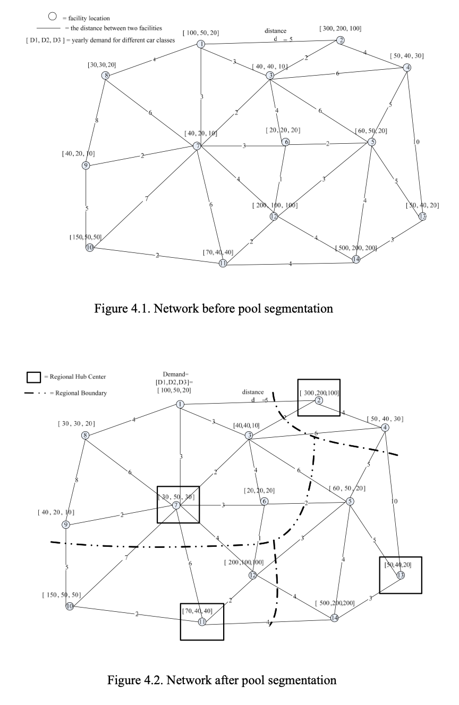

The algorithm we incorporate to realize the pool segmentation is a simplified heuristic algorithm, which comes very handy when solving regional optimal management problems using specific characteristics. Before applying the model, it’s necessary to determine the number of management centers, $p$, based on the management need. The major goal of the algorithm is to assign rental sites to pools that minimize the transportation costs, which is denoted by $Z$. Then, the algorithm can be achieved as follow:

1. Calculate distances between adjacent rental sites and put the distances in a set $D$. Get a set of management center candidates, $M$, the size of the candidates set $m$ is usually greater than $p$. Also acquire a set of demand amplitudes for each site, denote by $H$.
2. Currently let the number of management centers $K=m$, that is select all the candidates. Assign each site to the closest center for all other sites and those $K$ centers. Obtain the total transportation costs $Z$.
3. If $K=p$, go to Step 6. Otherwise, go to Step 4.
4. Take away one center from the $K$ management centers and assign it to another management center, make sure the minimum increase of the transportation costs.
5. Delete that center taken away in Step 4 from $M$, let $K=K-1$ and go to Step 3.
6. Check that the maximum distances and demand amplitudes in each pool are no greater than the maximum in $D$ and $H$. If there is(are) such site(s) in this original result, then take out the site(s) and in this case it’s necessary to form an extra new pool to adjust for the costs and demand. Export the result.

It’s not necessary to give the new pool formed by the taken-out sites due to restrictions in Step 6 a management center since the new pool is usually small. If the new pool is large enough, an additional regional management center can be added if there’s enough investment. On the other hand, a reconsideration on the original assignment might seem to be a better choice in this case.

The heuristic algorithm and pool segmentation provide a very efficient way to partition the market and encourage more flows of fleets and accomplish a better utilization.

In addition to the general problems and methods explained above, large companies like Enterprise also have their own managing features to pump up efficiency and gain revenues. For example, Enterprise uses a method called total cost of ownership (TCO) to accurately keep track of the ongoing expenses of each vehicle. The TCO analysis on fleets can help managers better understand the operational efficiency of each car and thus plan accordingly. They also provide outsourcing service as a manner of consulting and lend fleet management services to small companies, which cannot afford to build a comprehensive management system themselves.

**IV. CAR RENTAL AND FLEET PLANNING PROBLEMS**

Rental car industry leaders and experts categorize “Car Rental Problems” into three separate primary categories: revenue management, the hydrogen car phenomenon, and fleet management. Revenue management is known as the task of best balancing supply and demand to maximize profit. In 2004, a system was proposed using a mathematical model that generated minimum acceptable prices and number of cars available for renting at a given price as a function of remaining time and inventory. However, while partially adopted by many companies throughout the industry, the primary issue with this model was its limited application to a single rental period and a single car class. Pundits claim that allowing either of those two things would threaten customer satisfaction and lead to consumers favoring rental car alternatives.

Additionally, the notion known across the industry as the “Hydrogen Car Phenomenon,” is based off of a survey done on 435 consumers in 2008 that found that people are willing to pay more to rent pollution-free cars. Ultimately, sparking great debate across the industry regarding optimal fleet purchase cost (and the subsequent fleet quality) and how much consumers care about a car they will only use for a short period of time. Lastly, the category known as “Fleet Planning Problems” is separated into three categories (all according to timing): Pool Segmentation and Hub Selection (Long-term), Inter-pool Moves and Asset Replacement (Mid-term), and Demand Allocation and Empty Flow Redistribution (Short-term). Pool segmentation and hub selection is the practice of forming regions of multiple rental car locations, with each having a primary hub to help with distribution. However, when various members of the industry model this practice, there are disagreements between whether it should be categorized as a capacitated facility location problem with a single source constraint (meaning that the initial cost of the hub would be included) or a generalized assignment problem (initial cost is not included) when modeling and choosing whether to apply this practice. This is the reason that many car rental agencies did not initially implement this practice when it was initially introduced. Next, inter-pool moves and asset replacement is defined as the strategic fleet plan into a network flow problem. Essentially, rental car agencies attempt to move their fleets from hub-to-hub on a seasonal basis to meet and maximize locational demand while minimizing the required total cost (and size) of their fleet. Finally, demand allocation and empty flow distribution uses a network model, a simulation model, and common industry issues/practices (eg. multi-period planning, a country-wide network, fleeting and defleeting, and car groups with partial substitutability) to address which policies to adapt on a company by company basis. The most polarizing debate and essential business decision is what car upgrade policy each organization should adapt, leading various types of consumers to prefer one car rental agency over another. Ultimately, we considered all of these problems when forming our decisions and choosing our proposed solutions, keeping in mind the diverse preferences across the rental car industry.

**V. PROPOSED SOLUTIONS**

In order to address the problems mentioned above, we propose two possible solutions.

The first solution is to simplify the diversity of the fleet and overpopulate the fleet with cheap cars. This is a very convenient and easy method for companies to implement. As stated in section II, reselling cars has become a major revenue source for car rental companies, and having a cheaper fleet also makes the companies easier to resell their fleet down the line, as there would not be a lot of bargaining and negotiating. More importantly, overpopulating the fleet with cheaper cars requires a much lower initial cost than overflow center, which is another solution that will be discussed next. It’s extremely friendly to those small companies or companies that are experiencing some sort of financial crisis, because usually they do not have enough funds to invest on other management centers, cars, or infrastructures. Furthermore, this method also allows firms to be able to afford to be inefficient in the utilization of fleets, since the revenue loss due to the inefficiency is lower for the cheaper fleets.

However, this method holds obvious drawbacks. Since the diversity of the fleet is simplified, customers would have less choices on the types and classes of the vehicles. Additionally with the decreased quality of the fleets, customers would have an overall worse experience renting cars. This could lead to a potentially immutable harm to the demand and popularity of the whole industry. The opportunity costs of this method could be profound.

The other solution is to add an overflow center, in addition to the regional management center in each segmented pool. The demand problem most rental stations face is caused by the contractual obligations combined with customers' reservations and walk-in demand, which can exceed the rental car lot supply. An overflow center can help each pool to better control the supply. Note the image below for reference as to how the overflow center would fit into the current pool segmentation scheme:

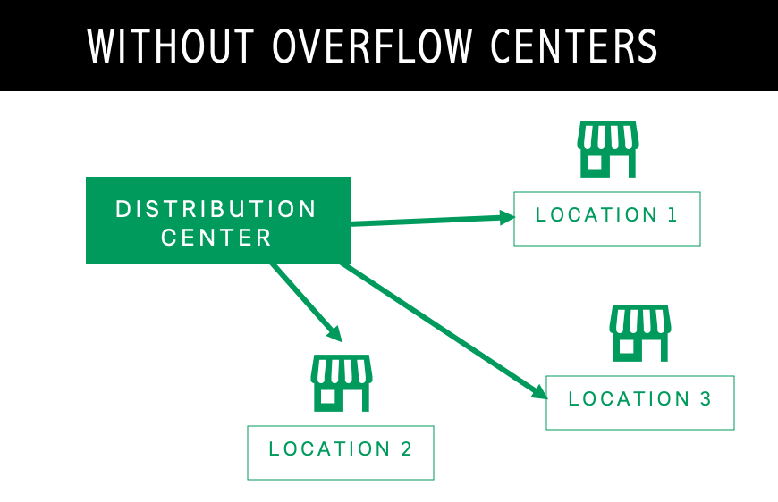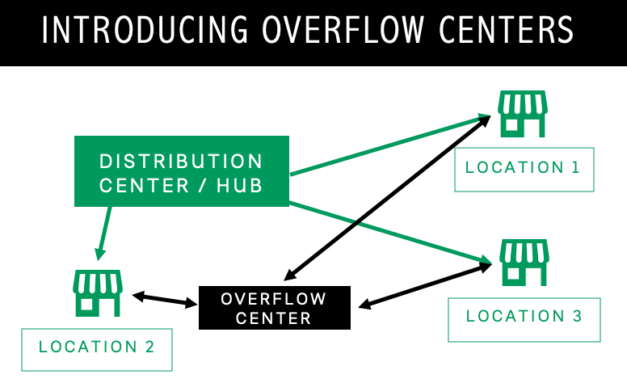

The usage of an overflow center is to hold the excess supply from each rental station, and rental stations where demand exceeds supply can obtain inventory from the overflow center. Basically, an overflow center serves as an intermediate fleet control center who decides how many additional vehicles to send to some rental stations and simultaneously collect the redundancy from other stations to guarantee for enough supply. In general, the implementation of the overflow center can help prevent demand exceeding supply by allowing each rental station for more than one restock per day. Overflow center also creates more circulation for the vehicles between stations, which allows companies to have fewer waste resources and nicer fleets. As a result, by implementing overflow centers, flexibility can be attained in inventory management for effectively dealing with daily customer demand. In addition, significant transportation and inventory cost can be saved by adding overflow centers.

**CONCLUSION**

While the method of pool segmentation does significantly improve the efficiency of rental car allocation, there still presently exists the problem of how these pools face the uncertainty and volatility of consumer demand. This especially becomes an issue as the segmented pools in the current system have no way of communicating with one another in the face of fleet shortages or overflows. Thus, our proposed solution of introducing the overflow centers could help to somewhat alleviate this problem as it allows these new centers to communicate with one another across pool divisions and thus help in managing company-wide fleets. Still, this solution does have the drawback of requiring a large initial investment which makes the alternative of simplifying the diversity of the fleets more appealing.

As indicated by the in-class poll, the preferred solution among consumers may in fact be to simply lower costs, by investing in a larger quantity of cheap cars. The participants of the poll, all young adults, probably have more experience with the use of rideshare or carshare programs, rather than the more traditional car rental, and would only choose car rental if it was the cheaper and more convenient option. Solving the allocation problem, without further catering to the newer market of young adults, will not save the car rental industry from competition with rideshare companies.

Though the overflow center solution may help alleviate costs in the long term, it will also incur a high initial investment. Even with competition only among other traditional car companies, the overflow center plan could raise costs too high in the short term. Despite allocation efficiency advantages of overflow centers, high initial costs, changing consumers and a changing market may prevent companies from implementation.

**REFERENCES**

1. Yeager, M. (2020, March 26). Rental cars are stacking up in Arizona as coronavirus keeps travelers away. Retrieved from https://www.usatoday.com/story/travel/news/2020/03/26/coronavirus-unused-rental-cars-fill-parking-lots/2914390001/
2. Andreas Fink, Torsten Reiners. Modeling and solving the short-term car rental logistics problems. 2004. Institute of Information Systems, University of Hamburg, Von-Melle-Park 5, 20146 Hamburg, Germany
3. Gen-Han Wu. Fleet Planning in the Car Rental Business. 2010. The Pennsylvania State University
4. Yazao Yang, Wenzhou Jin, Xiaoni Hao. Dynamic Pool Segmentation Model and Algorithm in the Car Rental Industry.
5. Maria Beatriz Brito Oliveira. Fleet and Revenue Management in Car Rental: Quantitative Approaches for Optimization Under Uncertainty.
6. Julian E. Pachon, Eleftherios Iakovou, Chi Ip & Ronny Aboudi. A Synthesis of Tactical Fleet Planning Models for the Car Rental Industry. 2003. IIE Transactions.